Machine Learning Foundations
Professor. Prashanth L A
Department of Computer Science and Engineering
Indian Institute of Technology, Madras
Solving Fibonacci Sequence Using Diagonalization
Welcome to another lecture in week 4 of machine learning foundations. We will continue our discussion on linear algebra set of things here. In particular, we will be looking at a concrete example that shows the utility of diagonalization. This is the well known Fibonacci sequence. Suppose you want to calculate some higher or determine a Fibonacci sequence without doing it in the Brute force way.
But you are okay with good enough approximations, then one can use the linear algebra. One can use ideas from diagonalization which is the linear algebra route to understand what the higher order terms in a Fibonacci sequence are. That is exactly what we are going to do in this lecture.
(Refer Slide Time: 1:03)
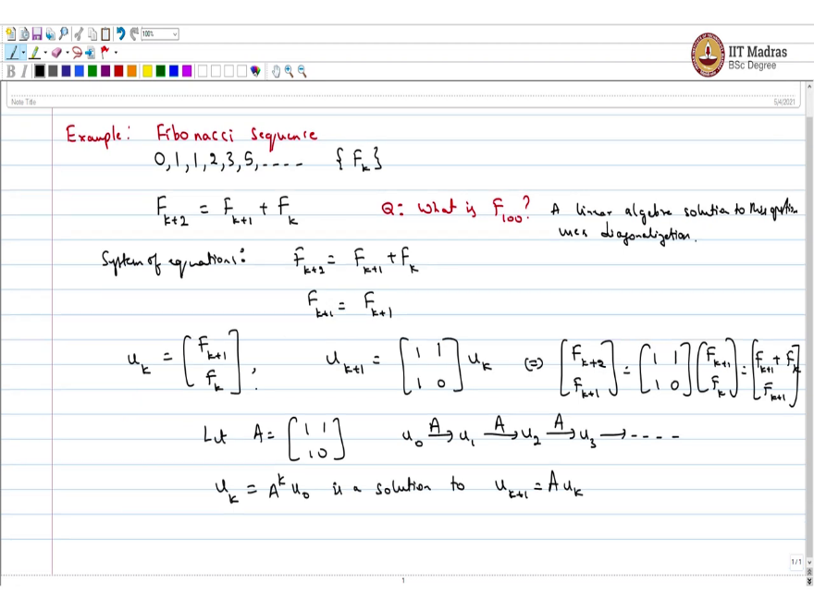
We will continue our discussion today on similarity and the diagonalization within detailed example. Which is Fibonacci sequence hope everyone is familiar with the Fibonacci sequence. And linear algebra would let us answer some interesting questions about the sequence. Everyone knows that start with 0, 1,1,2,3,5….. {Fn} Here we keep on adding the previous two numbers to get the next. So, it is like 2 + 1 is 3, 3 +2 is 5 and so on. This is the Fibonacci sequence.
If you want to write it as a recurrence relation so, this is a sequence this can be noted say F_{k} and F_{k + 2} is the sum of the previous two (which is F_{k + 1} + F_{k)}. Now, our question is if I am interested in knowing what is F₁₀₀? That is the question. Now, we could do this manually or let a computer program do it. But these questions can be answered elegantly using linear algebra.
Algebra solution to this of this question uses diagonalization. So, to start with, I need a matrix. So, let us write down a system of equations. Let us have the system of equations like this you have F_{k + 2} = F_{k + 1} + F_{k}. let us say k F_{k+1} will add a dummy equation which is F_{k + 1} is not changed this is unchanged. Now, if I let the parameter or the trade denote this if I look at this pair how it evolves, then if I want to write u_{k + 1} as some matrix times u_{k}, what would be that matrix?
Think about this. The answer is this. $\left[\begin{matrix}1 & 0 \\ 0 & 1\end{matrix}\right]$ simply because $\left[\begin{matrix} F_{k + 2} \\ F_{k+1}\end{matrix}\right]$ = $\left[\begin{matrix}1 & 1 \\ 1 & 0\end{matrix}\right]$ ×$\left[\begin{matrix} F_{k + 1} \\ F_{k}\end{matrix}\right]$ And you would get this $\left[\begin{matrix} {F_{k}+F}_{k + 1} \\ F_{k+1}\end{matrix}\right]$ which is the set of equations that we started with. So, what we have is let A denote this matrix $\left[\begin{matrix}1 & 1 \\ 1 & 0\end{matrix}\right]$, then we start with a u₀ which is[ 0, 1] and then keep on applying A we will get u₁ you apply A again we will get u₂ you apply A again you will get u₃ and so on. So, if I write u_{k} this is going to be A^{k} u₀ (A applied k times to u₀) and this is a solution to the system of equations u_{k + 1} = A u_{k.}
(Refer Slide Time: 5:07)
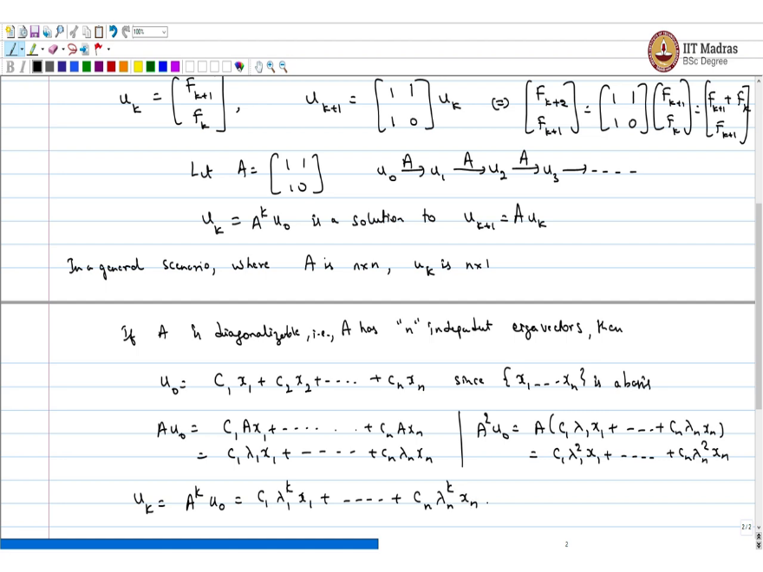
Now, how do I find u_{k} for that here is some ideas. if you have the set of equations not just Fibonacci in general scenario where A is n × n. And u_{k} is n ×1. Now, if A is diagonalizable that is A has n independent eigenvectors. Then start with u₀ so if u₀ can be written as some linear combination of these eigenvectors (u₀ = c₁x₁+c₂x₂+…...+c_{n}x_{n}) because these are since {x₁,….., xn} is a basis.
Now if I apply A on this I would get Au₀= (C₁ A x₁ +……. +CnAx_{n}) but these are eigenvectors. So, I would get (C₁ λ₁ x₁ +…..(so on until)….+ Cn λn xn). Now, what is u_{k}? u_{k} is just A^{k} u₀ and if I apply A again to this. So, what would be A² u₀? A²u₀ would be A (C1 λ₁ x₁ +….+ Cn λn xn) which is nothing but (C1 λ₁ ² x₁+……… + Cn λn² xn).
So, if you extend this logic further what you would get is you gets C1 λ₁^{k} x₁+…..+ Cn λ_{n}^{k} xn.
(Refer Slide Time: 7:52)
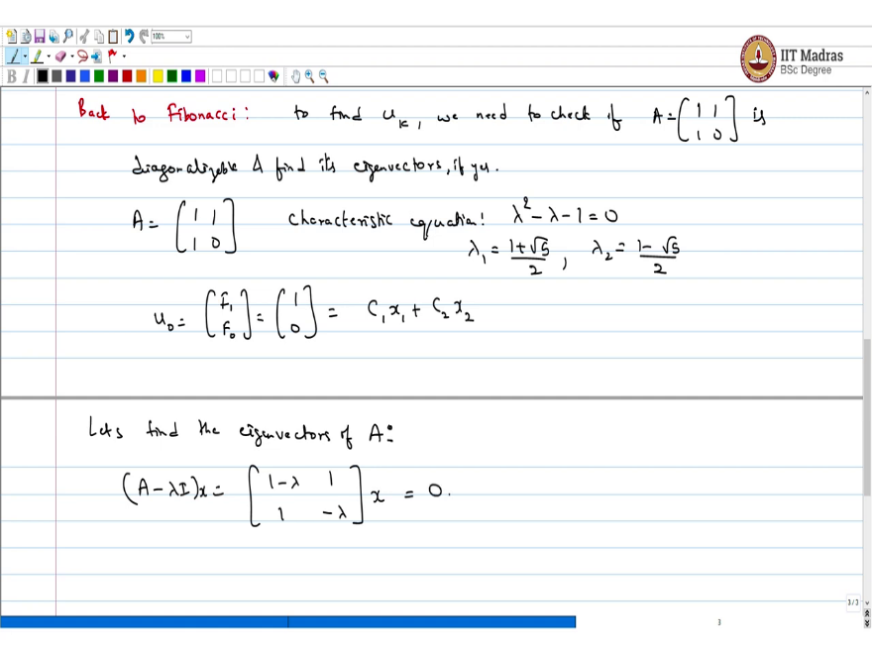
Now we will come back to Fibonacci. So, here to find u_{k} we need to check if A is $\left[\begin{matrix}1 & 1 \\ 1 & 0\end{matrix}\right]$ is diagonalizable and find its eigenvectors if it is diagonalizable. So, what is A? A is $\left[\begin{matrix}1 & 1 \\ 1 & 0\end{matrix}\right]$. So, just stop the video now and calculate this on your own what is the characteristic equation just λ² - λ -1 =0. This means λ₁ = $\frac{1+\sqrt{5}}{2} and$λ₂ ₌$\frac{1-\sqrt{5}}{2}$, this is the high school mathematics calculating the root for quadratic equation.
You started with u₀. Now, what is u₀? u₀ is$\left[\begin{matrix}F1 \\ F0 \end{matrix}\right]$ which is the first two Fibonacci numbers $\left[\begin{matrix}1 \\ 0\end{matrix}\right]$. I want to write this as C₁ x₁ + C₂ x₂ where x₁ and x₂ are the eigenvectors. So, what are the eigenvectors? Let us find the eigenvectors of A. What is (A - λ I). (A-λ I)= $\left[\begin{matrix}1-λ & 1 \\ 1 & -λ\end{matrix}\right]$Now, I want (A - λ I)x. and this I want this to be equal to 0.
(Refer Slide Time: 10:16)
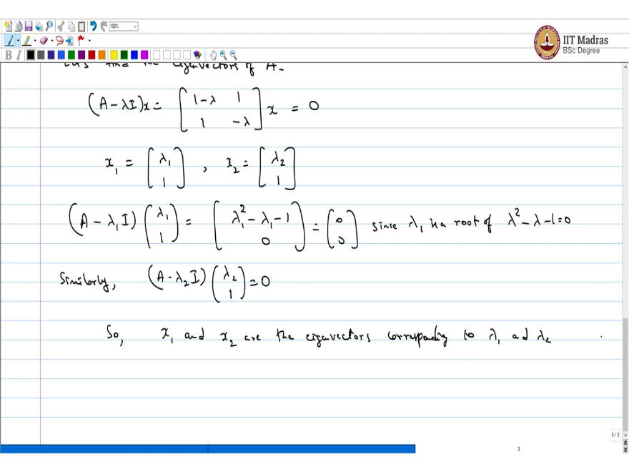
So, let us take x1 as $\left[\begin{matrix}λ_{1} \\ 1 \end{matrix}\right]$ and x2 as $\left[\begin{matrix}λ_{2} \\ 1 \end{matrix}\right]$ . What is (A – λ₁ I) × $\left[\begin{matrix}λ_{1} \\ 1 \end{matrix}\right]$. This is nothing but$\left[\begin{matrix}λ^{2}– λ -1 \\ 0\end{matrix}\right]$.= $\left[\begin{matrix}0 \\ 0 \end{matrix}\right]$But we know look at the characteristic polynomial. Since λ₁ is a root of λ² - λ -1=0. So, this is nothing but 0 . Similarly, (A- λ₂I) × $\left[\begin{matrix}λ_{2} \\ 1 \end{matrix}\right]$ = 0. So, x₁ and x₂ are the eigenvectors corresponding to λ ₁ and λ₂. Now, once we have this we got the basis and we can write u₀ as a linear combination.
(Refer Slide Time: 11:42)
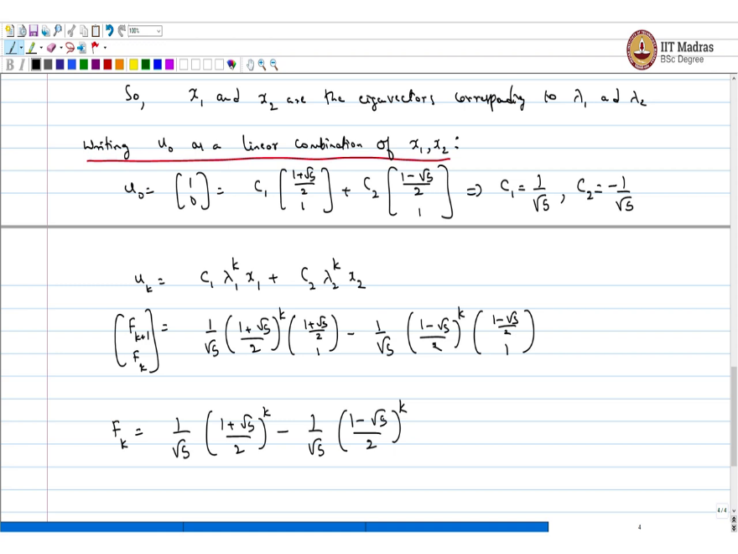
Now, writing u₀ as a linear combination of x₁, x_{2.} we want to do this. So, what is u₀, it is the same as first of two Fibonacci numbers at you can check it is like you want some constant times λ₁ which is if I substitute u₀₌$\left[\begin{matrix}1 \\ 0 \end{matrix}\right]$ ₌ C₁ $\left[\begin{matrix}\frac{1+\sqrt{5}}{2} \\ 1\end{matrix}\right]$-C₂$\left[\begin{matrix}\frac{1-\sqrt{5}}{2} \\ 1\end{matrix}\right]$
Now, you can just you know work backwards and find these as the constants just substitute and check you get C₁=$\frac{1}{\sqrt{5}} and C2=\frac{-1}{\sqrt{5}} .$
If you are not convinced minus 1 by square root 5. If you just do it like this you know the second term just cancels out 1 and 1. And the first term when you add these up you will get 1 just half + half and the other thing that is cancels out. What does this mean? So, what is u_{k}? u_{k} is nothing but C₁ λ₁ ^{k} x₁ + C₂ λ₂ ^{k} x₂. Which we just saw before which is the same as which is like same that
$\left[\begin{matrix} F_{k + 1} \\ F_{k}\end{matrix}\right]$if I look at this is equal to the constant here is $\frac{1}{\sqrt{5}}$ ${\left(\frac{1+\sqrt{5}}{2}\right)}^{k}\left[\begin{matrix}\frac{1+\sqrt{5}}{2} \\ 1\end{matrix}\right]-\frac{1}{\sqrt{5}}$ ${\left(\frac{1-\sqrt{5}}{2}\right)}^{k}\left[\begin{matrix}\frac{1-\sqrt{5}}{2} \\ 1\end{matrix}\right].$
(Refer Slide Time: 15:05)
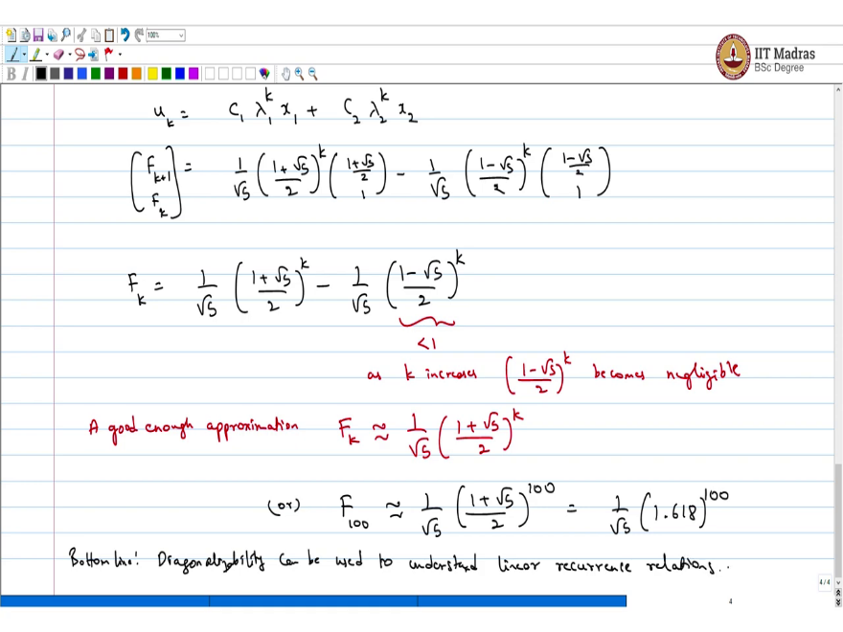
You can check this. This is less than 1. So, as k increases ${\left(\frac{1-\sqrt{5}}{2}\right)}^{k}$ becomes negligible. So, good enough approximation you just take the first number of F_{k} is you just approximate it by the first k number = $\frac{1}{\sqrt{5}}$ ${\left(\frac{1+\sqrt{5}}{2}\right)}^{k}$. Now, this is the same as or if you want the 100 number you can approximate this as $\frac{1}{\sqrt{5}}$ ${\left(\frac{1+\sqrt{5}}{2}\right)}^{100}$
Which is I think numerically $\frac{1}{\sqrt{5}}$ ${\left(1.618\right)}^{100}.$that is what you get. That is the 100th Fibonacci number. So, we can use so the point of this application is you can use diagonalizability to infer interesting things about linear recurrence relations. So, the bottom line of this application is diagonalizability can be used to understand linear so the important thing is this recurrence relation was linear.
What do I mean by that? If you go back to this equation here F_{k + 1} with all this. So, here this is u _{k + 1} is some linear function of u _{k}. But instead of this if I had a nonlinear function all of this analysis breaks down. So, this application works simply because you have a linear recurrence relation and we can use tools from linear algebra like the analyzability to understand what happens to the sequence or this relation after large number of iterations.
A quick recap before we end this lecture. In this lecture, we looked at a concrete example that illustrates the utility of diagonalization. In particular, one can use ideas from diagonalization of a matrix to solve linear recurrence relation and we took a popular example which is a Fibonacci sequence which is obviously a linear recurrence relation. So, for the Fibonacci sequence we made up our linear recurrence relation and that matrix underlying this relation be diagonalized.
And using the diagonalized form of this matrix which is it is a 2 × 2 matrix. We could get the eigenvalues and the eigenvectors of this. Using this we are able to come up with a very good approximation to higher order terms in the original Fibonacci sequence. For example, in this class in this lecture we saw how to calculate the 100th term of Fibonacci sequence without any brute force calculation by just using diagonalization calculating certain eigenvalues and eigenvectors.
And then using this information to calculate a higher order term. And this is a lot less compute intensive than actually doing some brute force calculations term by term. And this idea extends to a more general case where you want to solve linear recurrence relation. If you want to solve a linear recurrence relation then ideas from diagonalization are very, very useful.
In the follow up lectures what we will be looking at is the more I mean what is coming next is the spectral theorem which shows that any real symmetric matrix is diagonalizable and all its eigenvalues are real. Real symmetric matrix has only real eigenvalues. And these important claim which constitutes the spectral theorem is what we will be getting to in the next few lectures.

